It focused on developing the frontend interface of the EduGenie Learning Assistant using HTML, CSS, and Jinja2 templates. The main objective of this activity was to create a simple, responsive, and user-friendly interface through which users could easily interact with different AI-powered educational functionalities.
The frontend interface was developed inside the index.html file, where separate forms were created for functionalities such as:
Question Answering (QnA)
Concept Explanation
Quiz Generation
Text Summarization
Personalized Learning Recommendations
Each section included:
Input fields for user queries
Task-specific placeholders
Submit buttons for sending requests
Output containers for displaying generated results
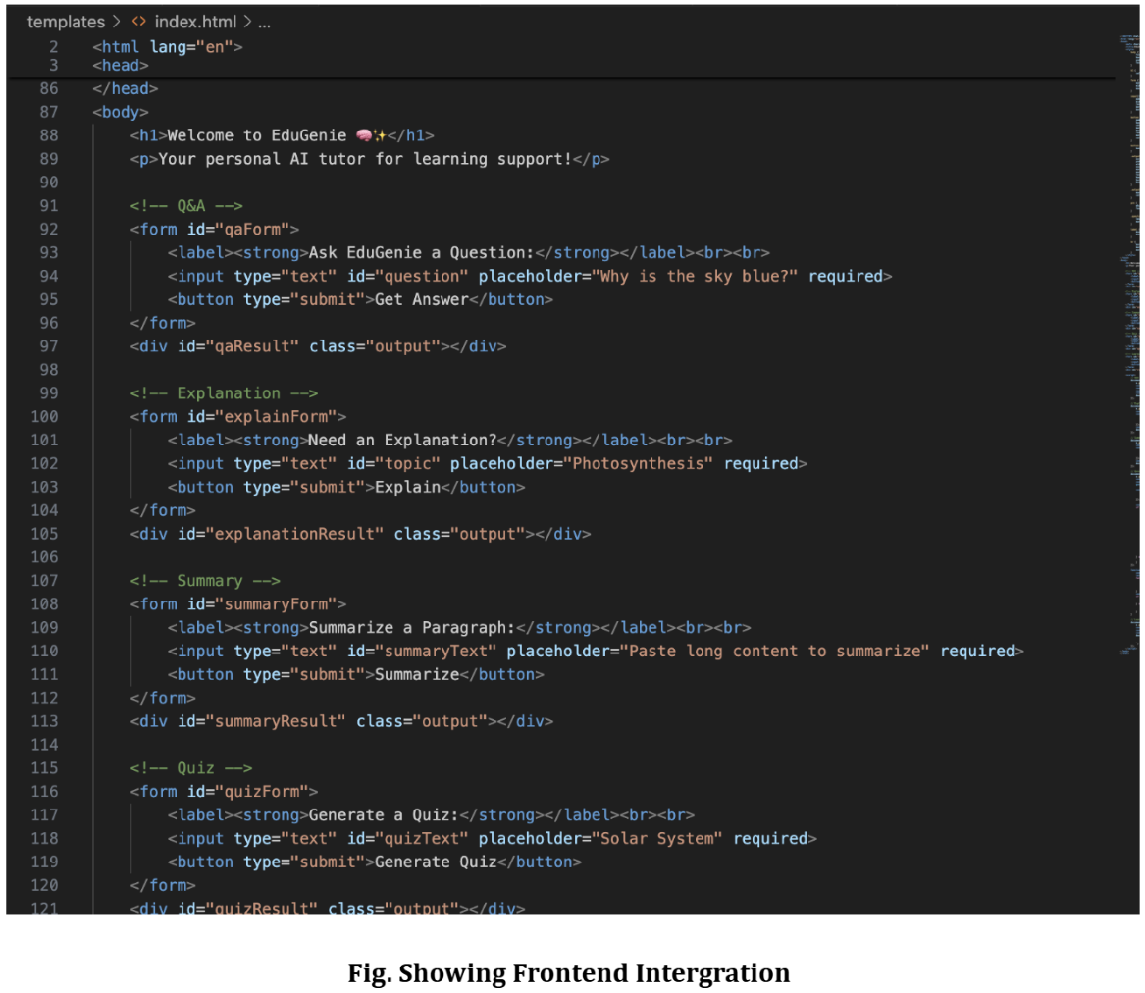
The frontend styling was managed through the style.css file, which provided:
Responsive web design
Styled buttons and text areas
Organized result containers
Improved user experience and readability
The interface was designed to ensure smooth user interaction while maintaining a clean and visually structured layout for educational assistance.
This activity successfully established the user interaction layer of EduGenie, allowing learners to access different educational services through a single integrated web interface.

